# Equality

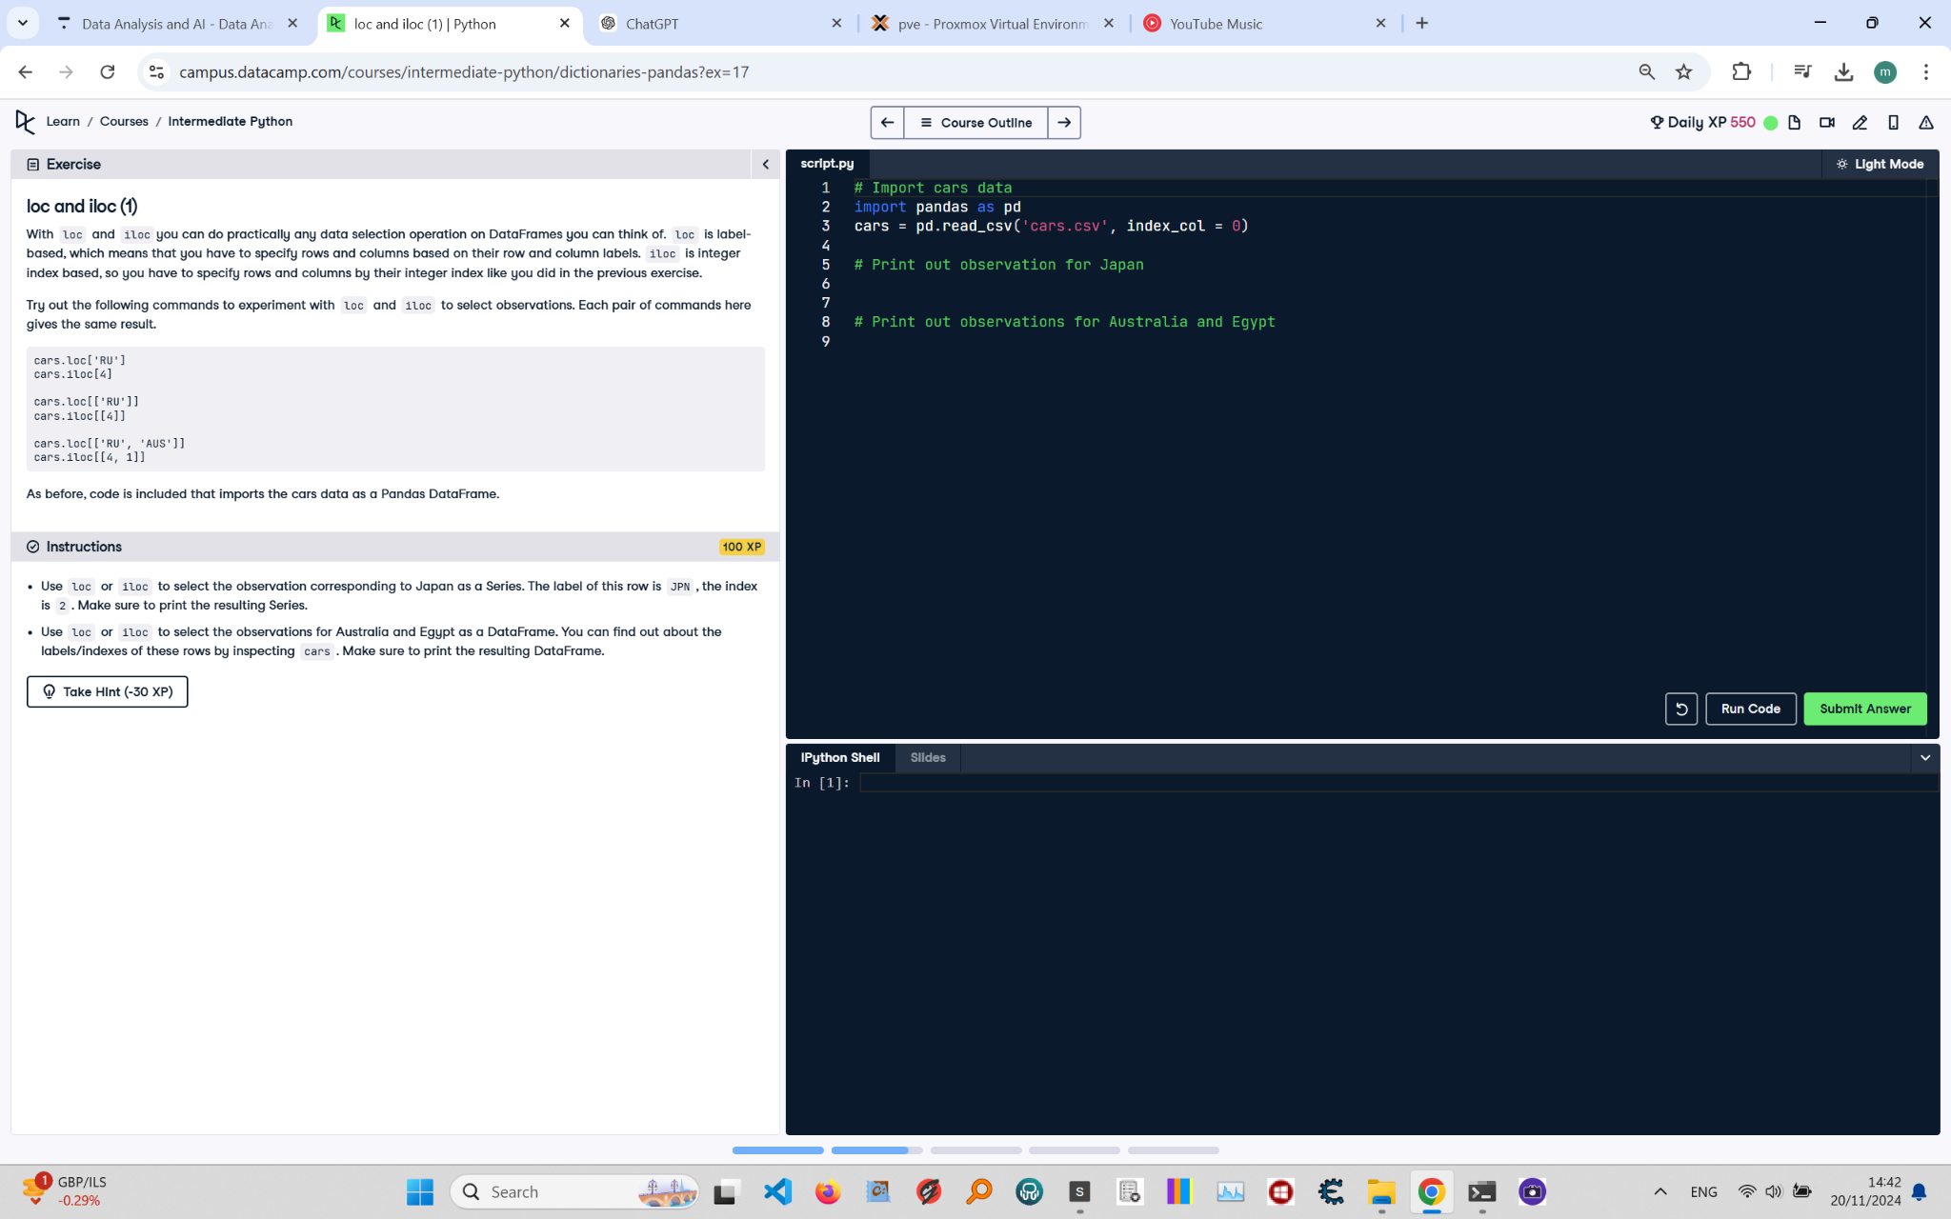

To check if two Python values, or variables, are equal you can use `==`. To check for inequality, you need `!=`. As a refresher, have a look at the following examples that all result in `True`. Feel free to try them out:  
```  
2 == (1 + 1)  
"intermediate" == "python"  
True != False  
"Python" == "Python"  
```  
When you write these comparisons in a script, you will need to wrap a `print()` function around them to see the output.

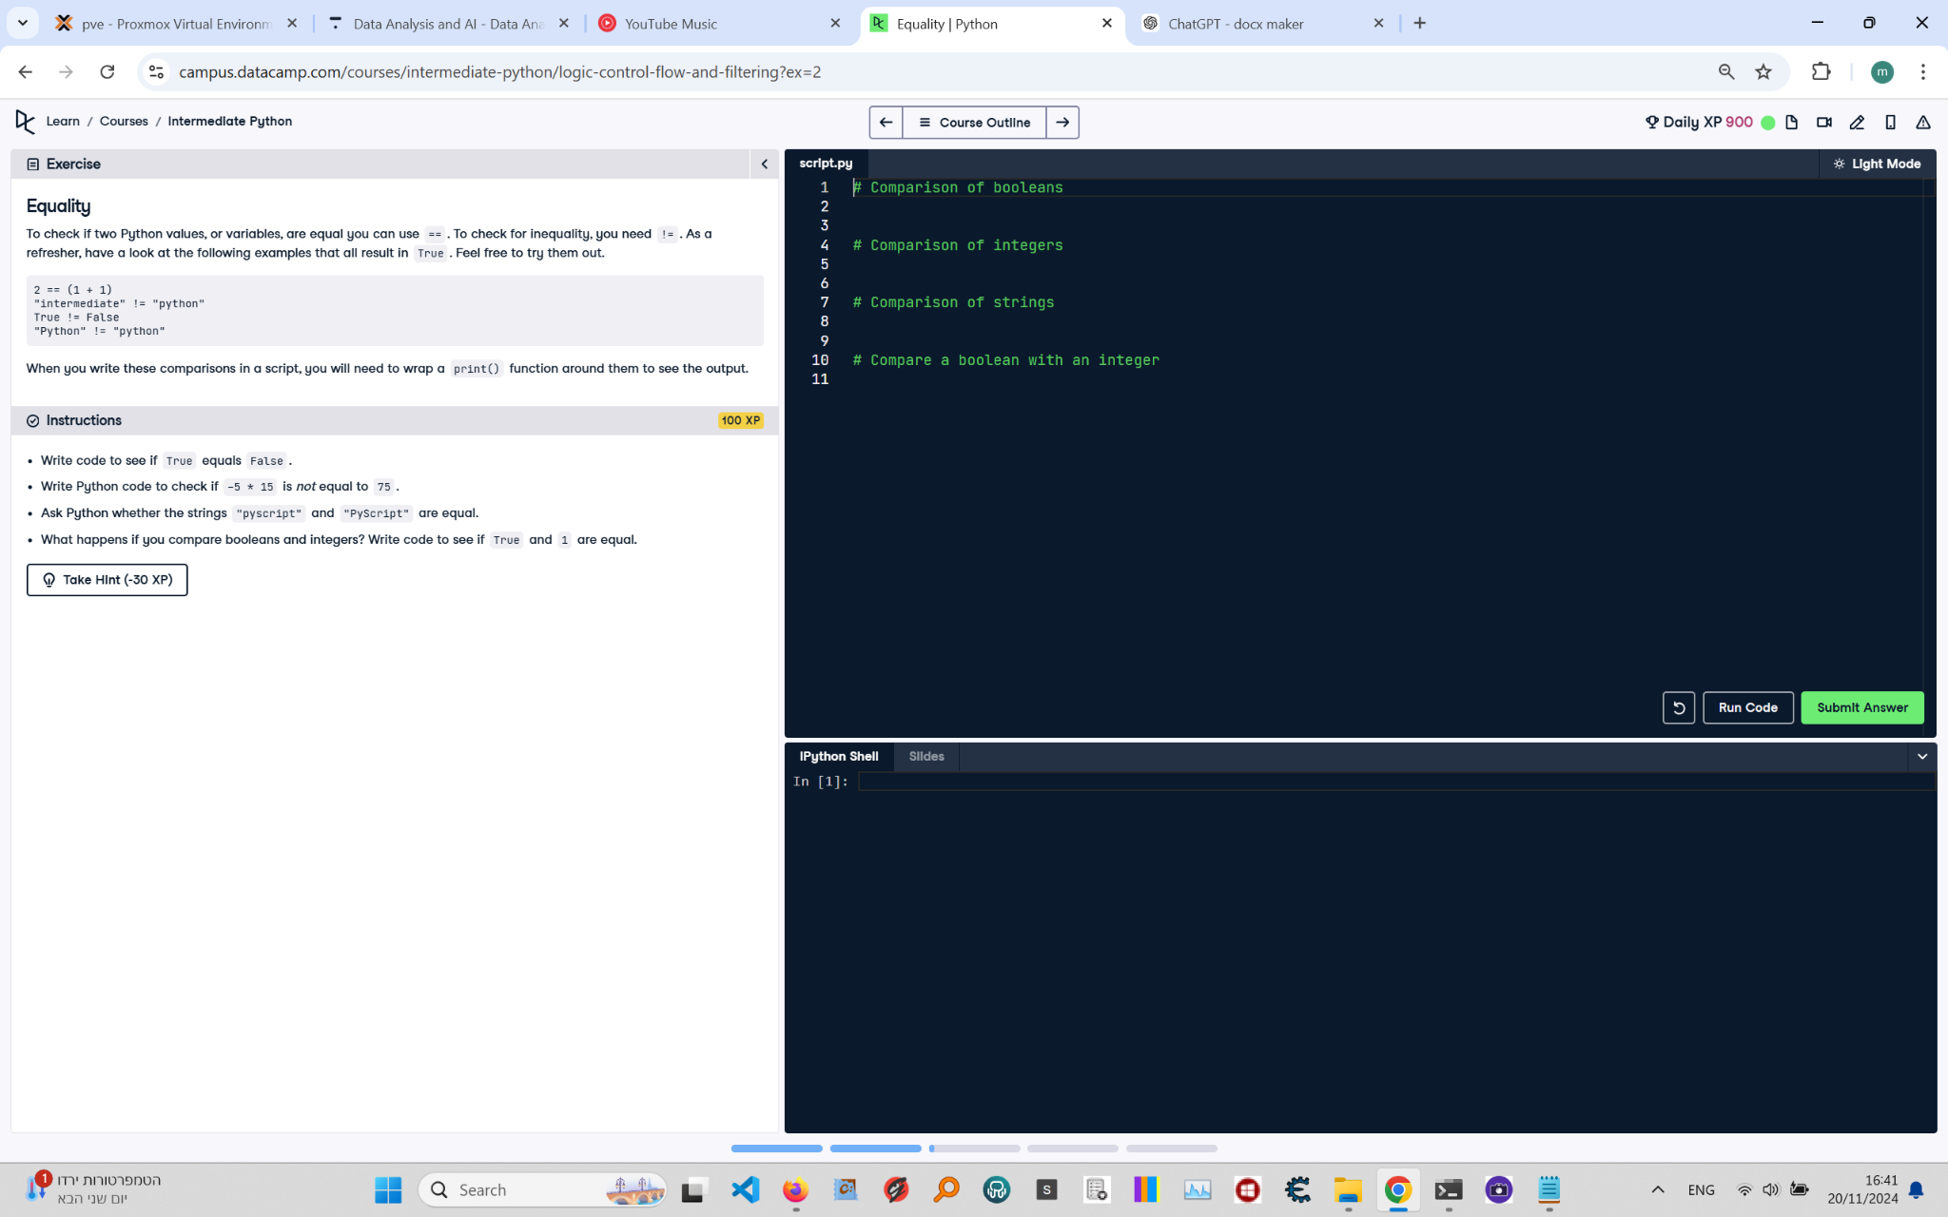

## Code Solution:

```python  
# Comparison of booleans  
print(True == False) # This checks if True equals False  
  
# Comparison of integers with correct operation  
print(-5 * 15 != 75) # This checks if -5 multiplied by 15 is not equal to 75  
  
# Comparison of strings  
print("pyscript" == "PyScript") # This checks if the two strings are equal  
  
# Compare a boolean with an integer  
print(True == 1) # This checks if True equals 1  
```

## Code Explanation:

1. `print(True == False)`: This checks if the boolean value `True` is equal to `False`. The result will be `False`.  
2. `print(-5 * 15 != 75)`: This checks if the result of `-5` multiplied by `15` is not equal to `75`. Since `-5 * 15` equals `-75`, the result of the inequality is `True`.  
3. `print("pyscript" == "PyScript")`: This checks if the string `"pyscript"` is equal to `"PyScript"`. Since string comparison is case-sensitive, the result will be `False`.  
4. `print(True == 1)`: This checks if the boolean value `True` is equal to the integer `1`. In Python, `True` is internally represented as `1`, so the result will be `True`.